


Department of Pharmacology
Post-Event Report: Pharmacology Quiz Competition
Event Title-PharmNimz-2026 Date-02/04/2026
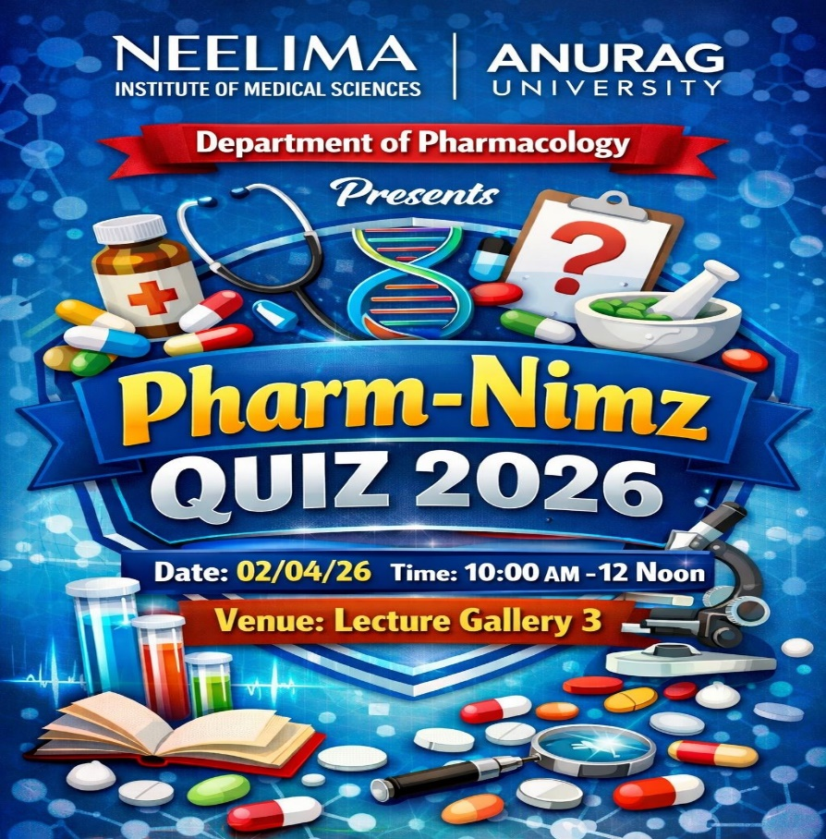

Background:
First a preliminary screening round was conducted for all the 150 Second Year MBBS students on Feb 2026 to ensure a competitive and merit-based selection. Based on performance, the top 12 students were shortlisted as finalists and advanced to the main quiz competition.
The “PharmNimz-2026” -Pharmacology Quiz Competition was successfully organized for the Second Year MBBS students at Neelima Institute of Medical Sciences on 2nd April2026.The event was designed to strengthen conceptual understanding, stimulate active learning, and promote the application of pharmacological principles across major organ systems. It provided an engaging platform for students to integrate theoretical knowledge with clinical reasoning in a dynamic and competitive environment.
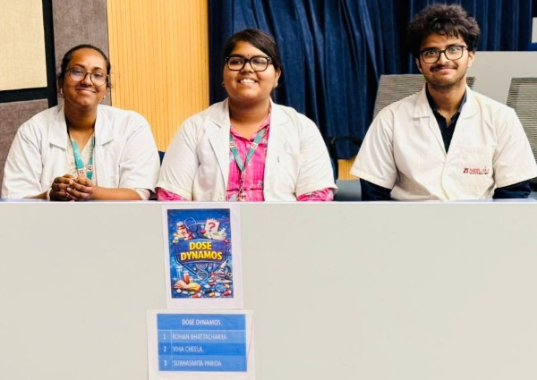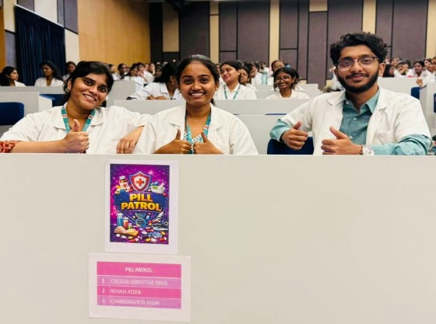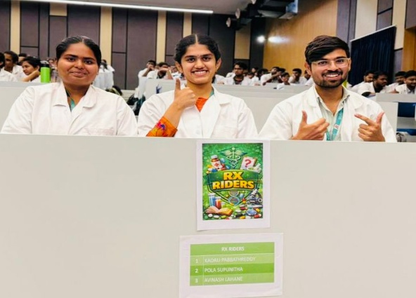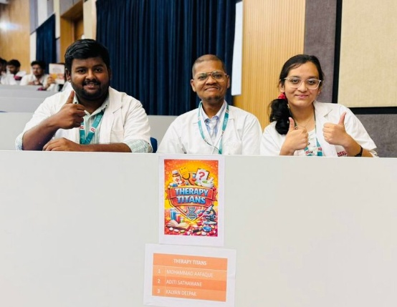

Objectives
- To reinforce core pharmacological concepts in an interactive manner
- To encourage clinical correlation and analytical thinking
- To promote teamwork and healthy academic competition
- To make pharmacology learning engaging and memorable

Structure of the Quiz
The quiz was thoughtfully designed with multiple innovative rounds to test different cognitive domains:
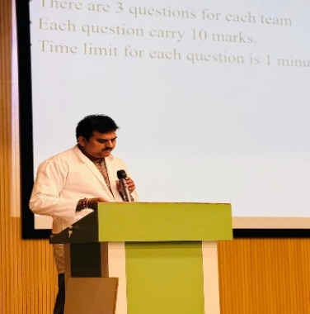
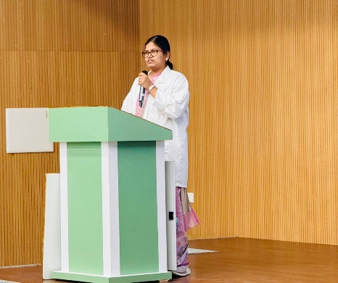
1. Link of the Links Round
Participants were required to identify a common connection between a series of clues. The round was than subdivided into-
- emoji based questions—to identify the drug names through emojis
- Mechanism of action of drugs
- Graphs depicting different pharmacological action of drugs.

2. Picture-Based Round
Visual questions included pictures of prominent Scientist,Sources of drug and adverse drug reaction images, testing recognition skills and applied knowledge.
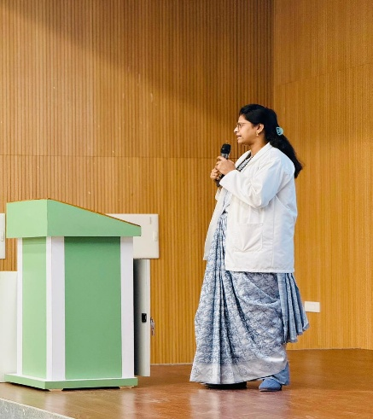
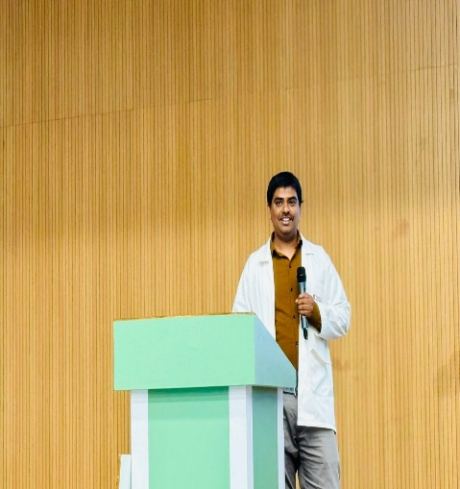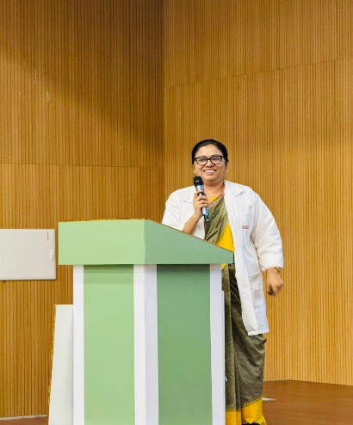

3. Mashup Round
A unique and engaging round where Bollywood song snippets were creatively linked with clinical diagnosis and drug of choice for that particular case.,adding a fun and memorable dimension to learning.
Also we presented case based questions to assess students’ ability to apply pharmacological principles in real-life clinical settings.
Pharmacology-themed riddles challenged lateral thinking and deep understanding of drug actions and classifications.
6. Treasure Hunt Round
A clue-based interactive round where teams solved pharmacology-related hints leading to successive clues, promoting teamwork, quick thinking, and active participation.
7. Rapid Fire Round
A high-energy round testing speed, accuracy, and recall under time pressure, serving as the final deciding stage of the competition.

Participation and Engagement
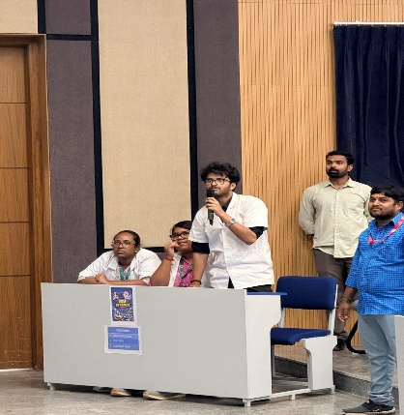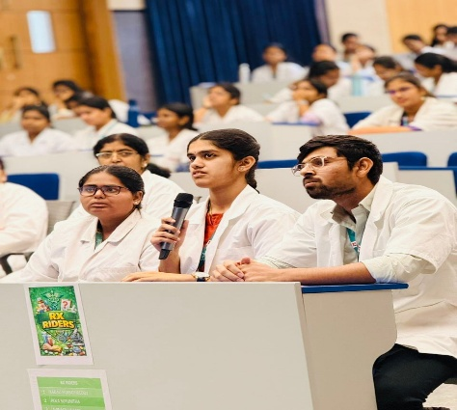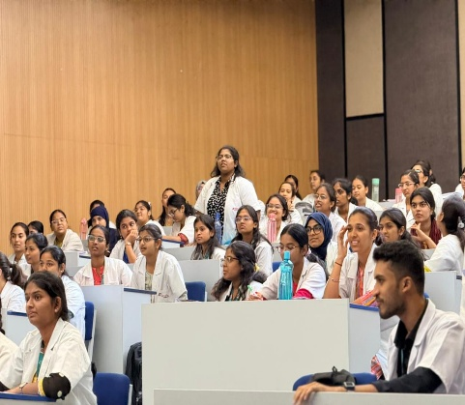
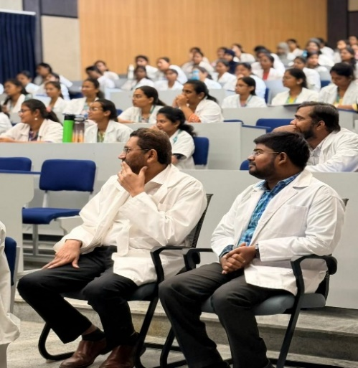
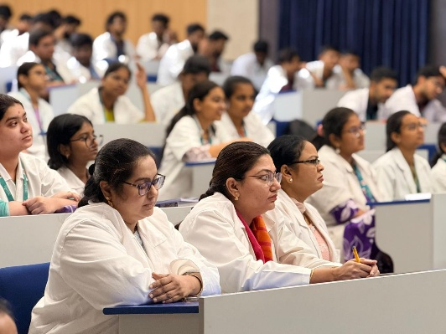
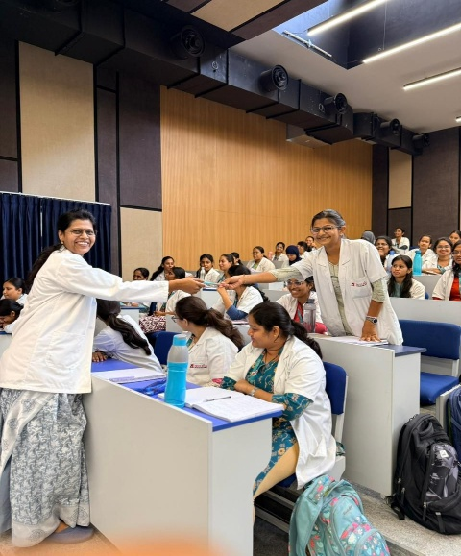
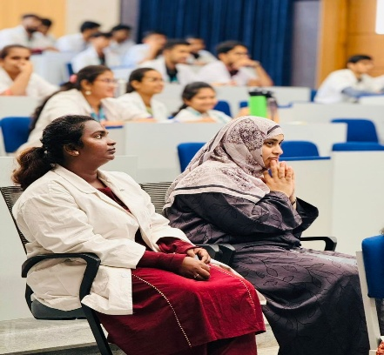

The event witnessed enthusiastic participation from 2nd Year MBBS students. Teams displayed commendable knowledge, quick thinking, and excellent coordination. The innovative rounds, particularly the mashup significantly increased engagement and made the session lively and interactive.

Conclusion
The “PharmNimz-2026” quiz Competition was a grand success, achieving its educational objectives while maintaining a vibrant and enjoyable atmosphere. The combination of traditional and innovative quiz formats ensured comprehensive learning and high student engagement.
Such initiatives play a crucial role in transforming conventional learning into an interactive and impactful experience. It is a humble suggestion that such similar academic activities be conducted regularly to sustain student interest and deepen subject understanding.
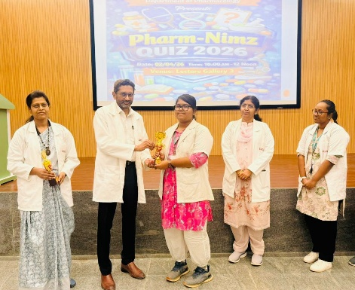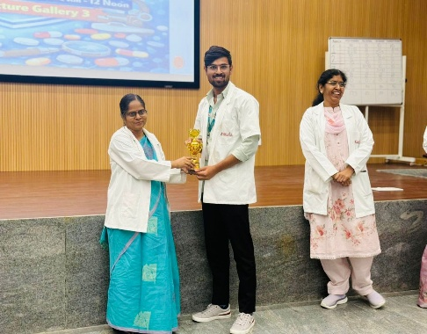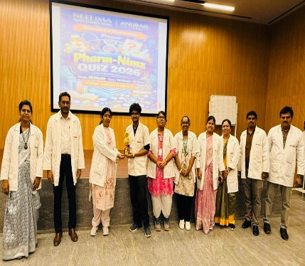
Acknowledgment:
The successful execution of the event was made possible through the constant support and encouragement of the management of Anurag University. We express our sincere gratitude to our respected Dean, Dr. Lakshmi Prasanna, for her guidance and motivation. We also acknowledge the dedicated efforts of the faculty members, the organizing team, and the enthusiastic participation of the students, all of whom contributed significantly to the success of the event.
